|  |  |  |
| --- | --- | --- |
| Member 1 | Nabh Sanjay Mehta | NSM190002 |
| Member 2 | Anil Kumar Yadav Kare | Axk190056 |
| Class | BUAN 6312.003 | Thursday 4-7PM batch |

Q 2.1: What is the conditional expectation function or population regression function?

Ans:

* It states merely that the expected value of the distribution of Y given Xi is functionally related to Xi.
* In simple terms, it tells how the mean or average response of Y varies with X.
* E [YjXi] is a function of Xi: E [YjXi] = f (Xi)
* PRF E(Y | Xi) is a linear function of Xi, say, of the type: E(Y | Xi) = β1 + β2Xi
* β1 and β2 are known as intercept and slope coefficients, respectively.
* Example

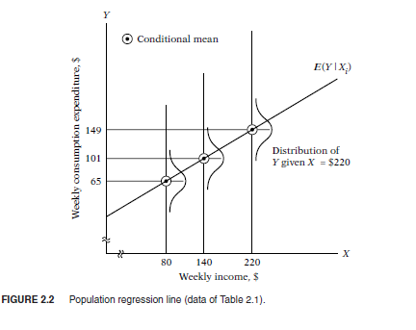

The graph shows average expenditure Y given that Weekly Income is X.

Ex. Here in graph, Average expenditure is $ 149 given Income for that week is $ 220

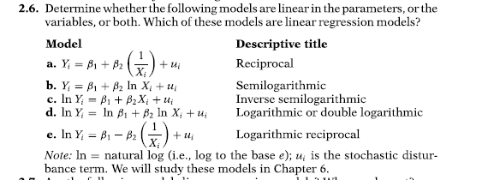

Ans: a, b, c, e has linearity in parameters. In (d) If we assume ln β1 = α then it will also be a linear equation.

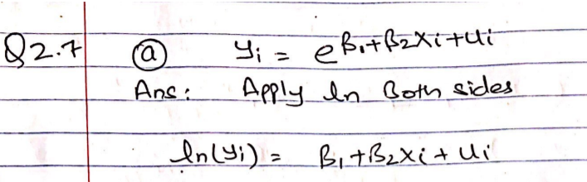

Ans: After applying natural log (ln), it becomes a Linear Regression equation

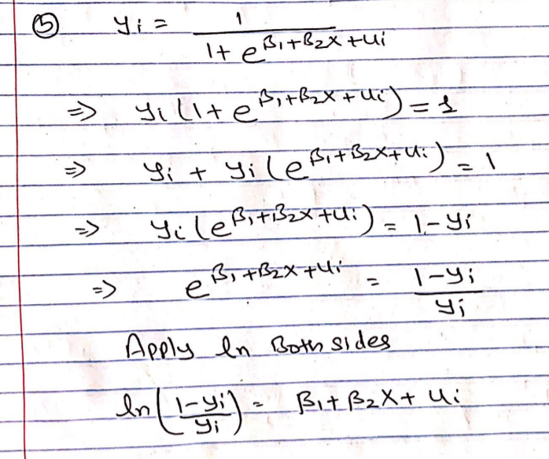

Ans: After applying natural log (ln), it becomes a Linear Regression equation



Ans: It is a linear regression equation

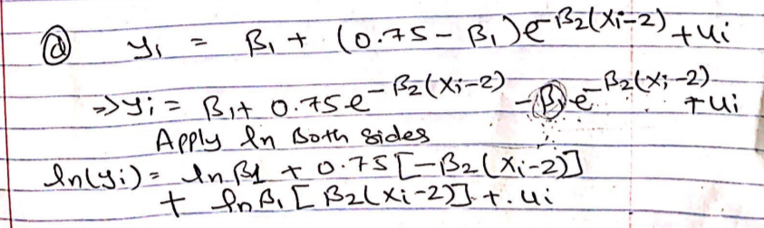

Ans: After applying natural log on both sides, we came to conclusion that it is a non-linear equation.



Ans: β2 is raised to power 3 so it is a non-linear equation

Q 2.14

Part a: We are observing a positive relationship between the two. We believe if unemployment increases, the labor force tries to enter into employment via other available means

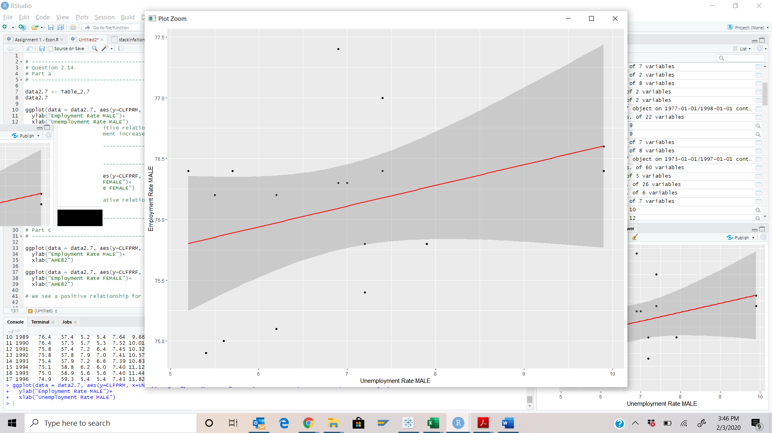

Part b: We are observing a negative relationship here. It seems like unemployment disheartens women to enter into work force again

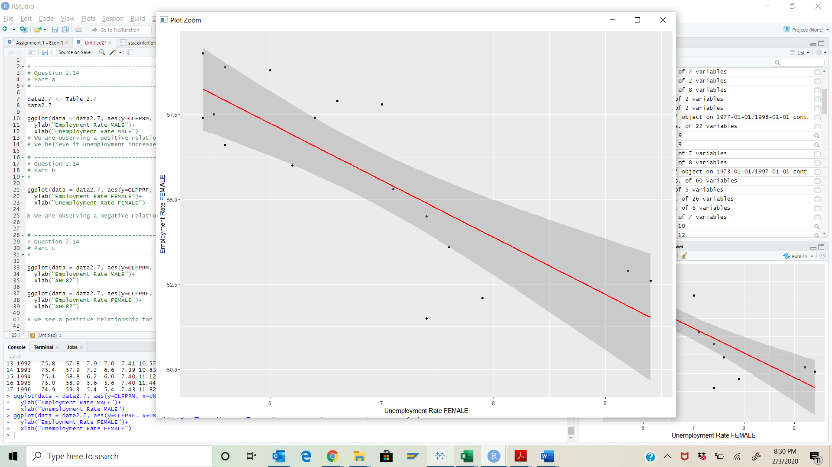

Part c: We see a positive relationship for Male workforce when hourly wages increases whereas a negative relationship for Female workforce

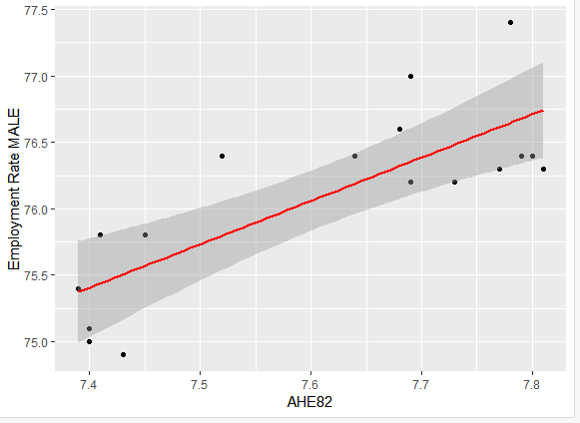

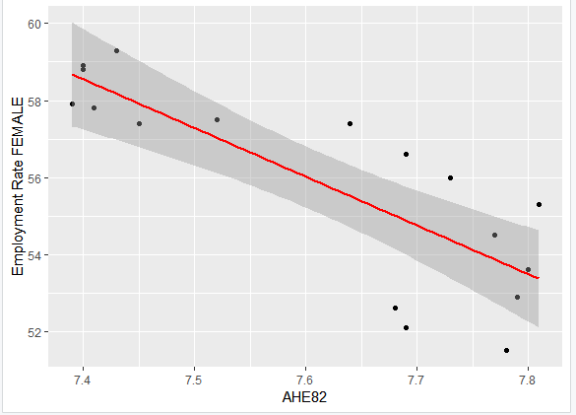

Part d: We need to perform multiple regression analysis for this question

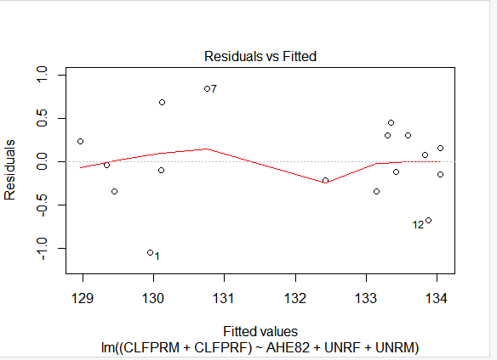

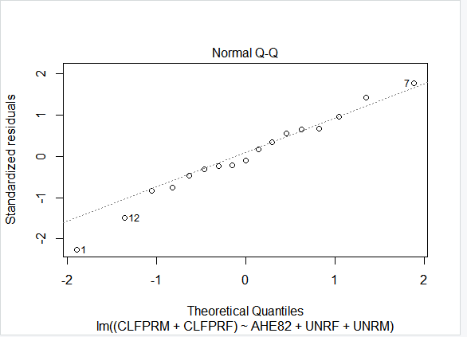

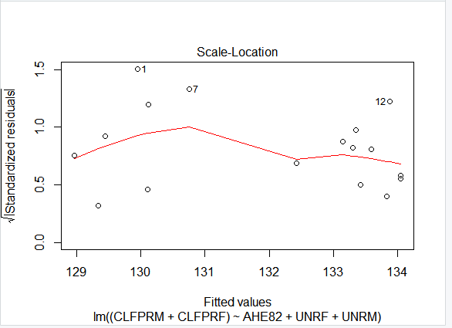

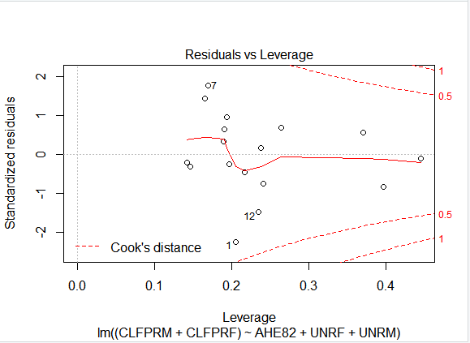

Q 2.15

Part a:

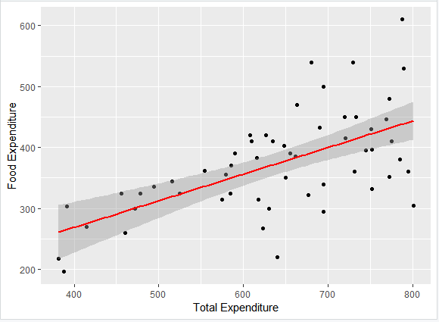

Part b: we can see a positive relationship here. As the total expenditure increases, the food expense also increases

Part c: Although we see a positive relationship here, we also observe high variability as the Total expenses increase, so we cannot assume relationship here to be always linear

Q3.1

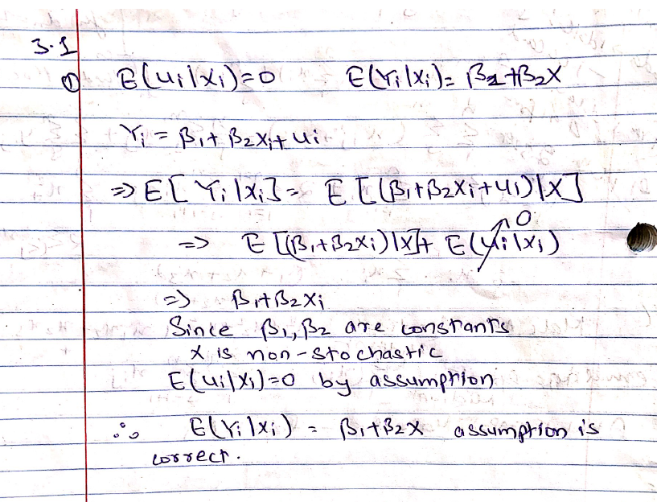

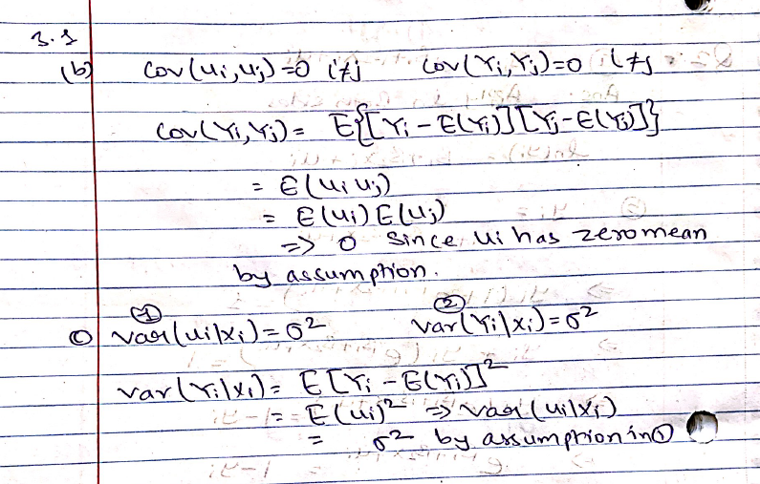

Q3.6

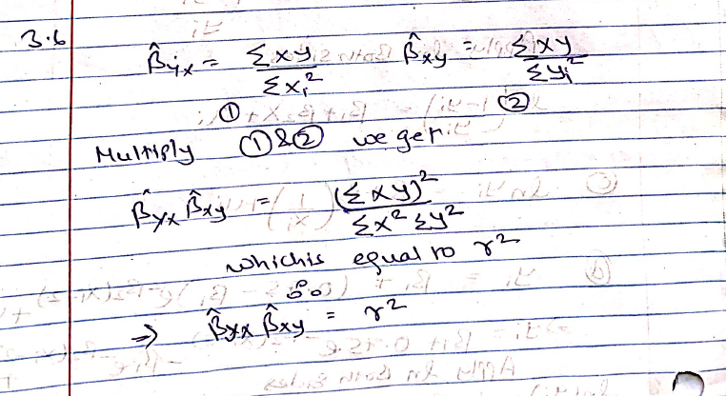

Q 3.7

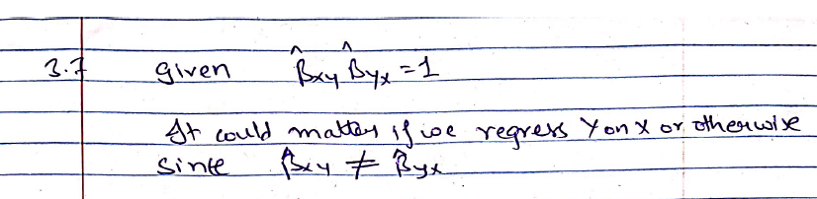

Q 3.9

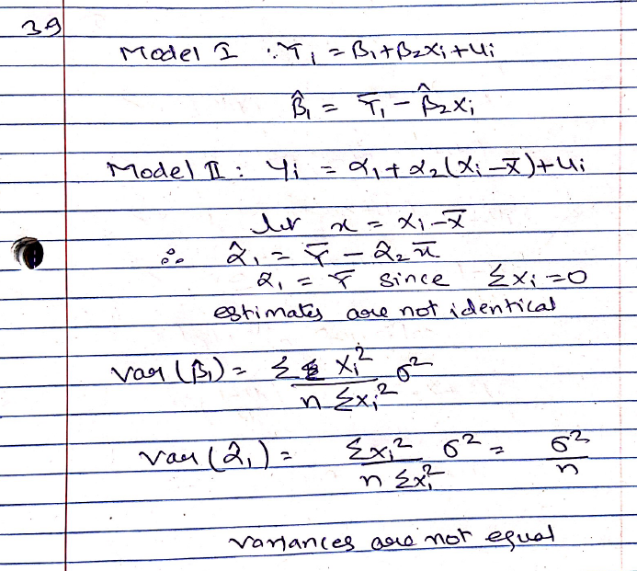

Q 3.10

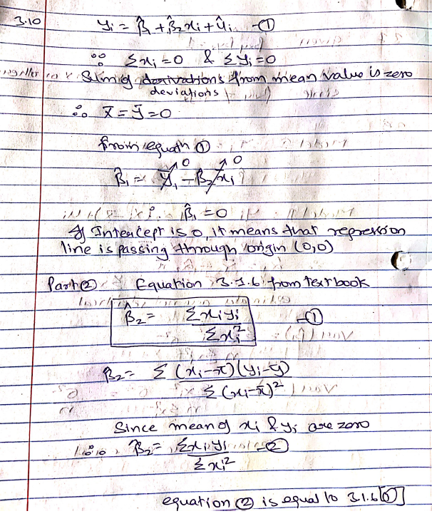

Q 3.11

